Microsoft Cloud Solution Center & Licensing

Pre-requisites and Deployment

Now that we understand what licenses are required to get started, we will move to understand how to deploy Microsoft Vaccination Management.

Dynamics components-based installations can be now deployed through a new portal-based experience known as the Microsoft Cloud Solutions Center. It is used to guide customers and partners through the deployment of capabilities for comprehensive Industry clouds such as MVM. The Microsoft Cloud Solutions Center is an orchestrator that simplifies the whole deployment process by checking licensing requirements and dependencies. It also brings in a unified deployment and configuration experience across multiple applications.

Pre-requisites

There are a couple of prerequisites before you begin deployment using the Microsoft Cloud Solutions Center:

* Enterprise required licenses for base platform dependencies.
* The user logging into the Solution Center should have either a Power Platform or Dynamics 365 administrator role to deploy MVM.
* User should also have the required licenses for MVM and its dependencies.
* Follow the Allow-listing process for MVM (see Lab 0: Environment Preparation & Prerequisites)

Deployment

The first step to deployment is to prepare the environment.

You will need an environment with Dataverse, so when you create a new environment in Power Platform Admin Center, you will have to select ‘Create a database’ for this environment. You will then you will install dependencies as required.

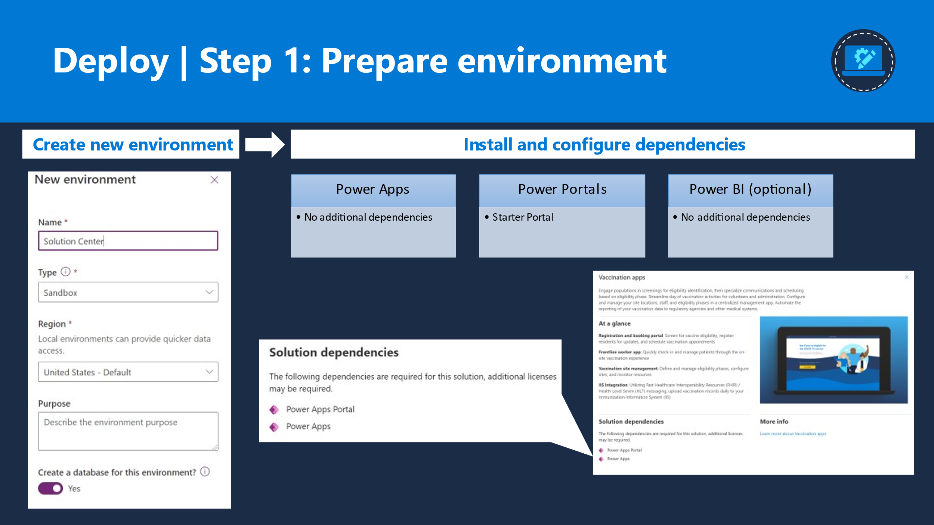

Once your environment is prepped up with a database and dependencies, you will then move to the next step to select the required Healthcare solutions to install. You can either choose one or many capabilities in one go, select add and kickoff the installation process.

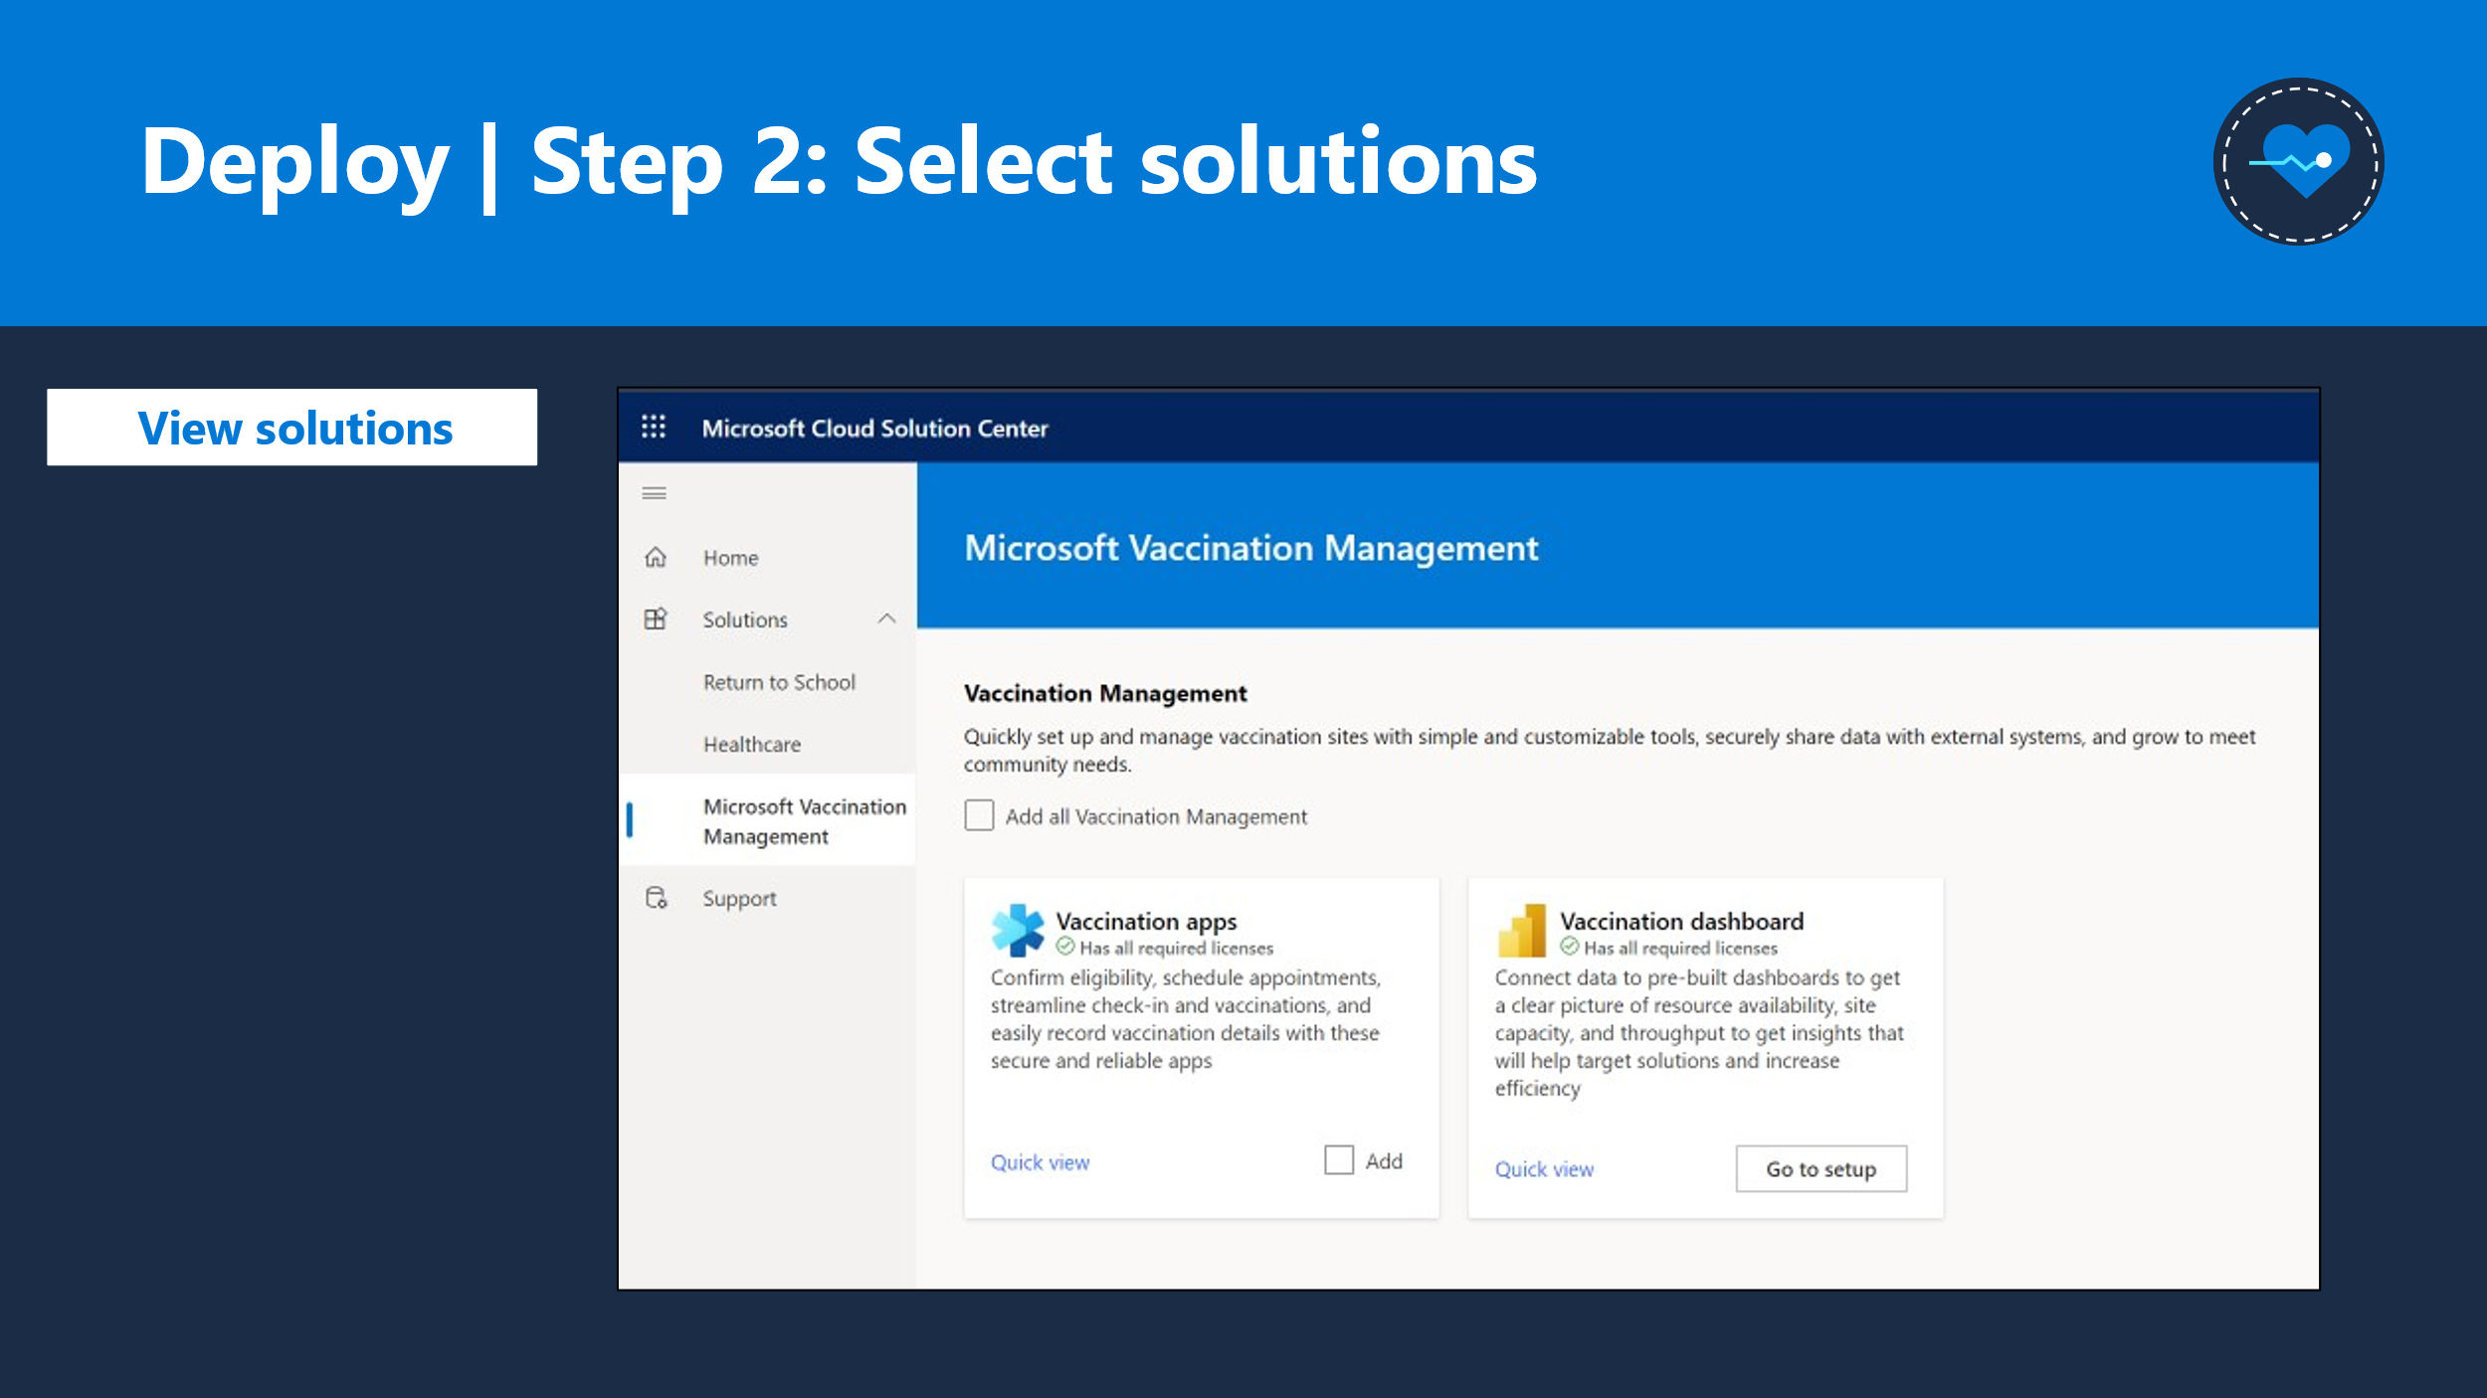

You will be prompted with the Org picker dropdown which has a list of all orgs on your tenant. If you have just created your environment and not seeing your org in the list, give it a few minutes before you retry, and it should reflect there.

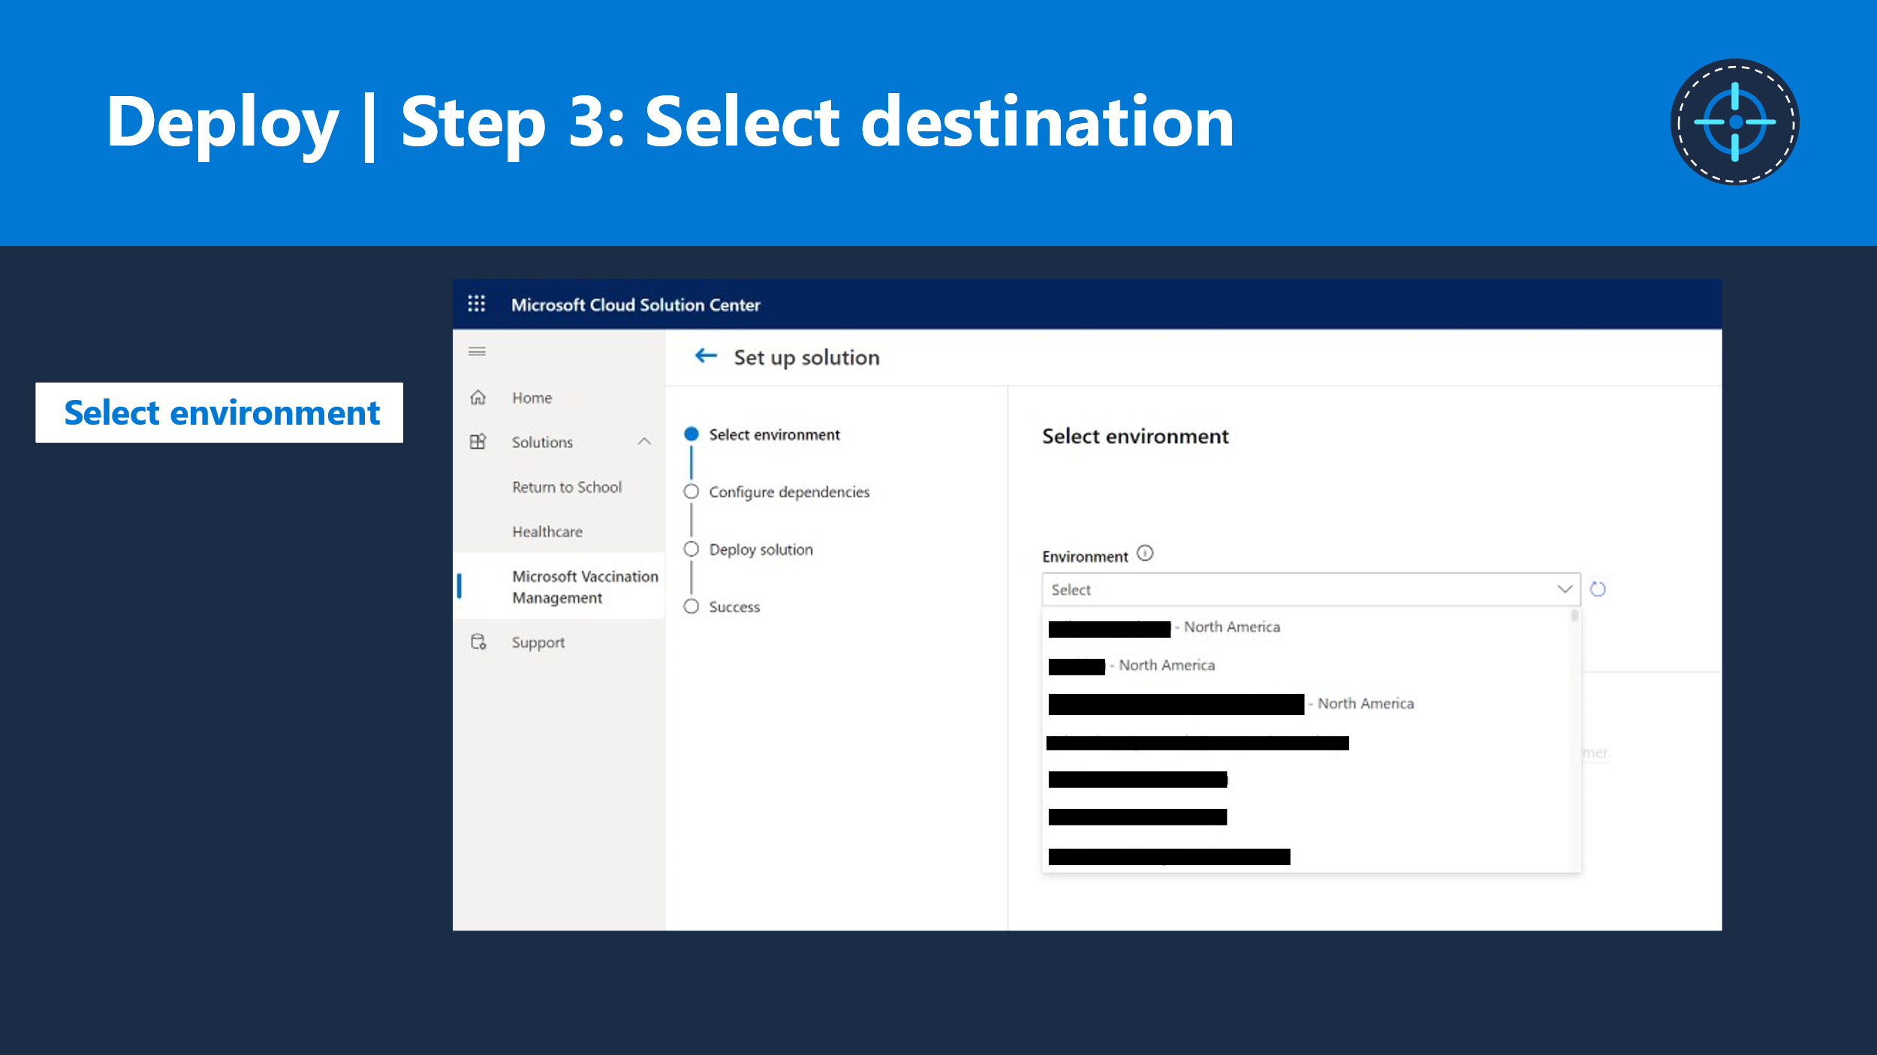

When you select an environment to install, the Solution Center runs a dependency check in the background to make sure you have all that you need to get the solution working. For example , here<point to screenshot> you see that the org does not have the Dynamics Marketing and Power Apps Portal dependencies pre-installed before they kicked off the installation process. Hence, they see this error and need to fix before they can proceed.

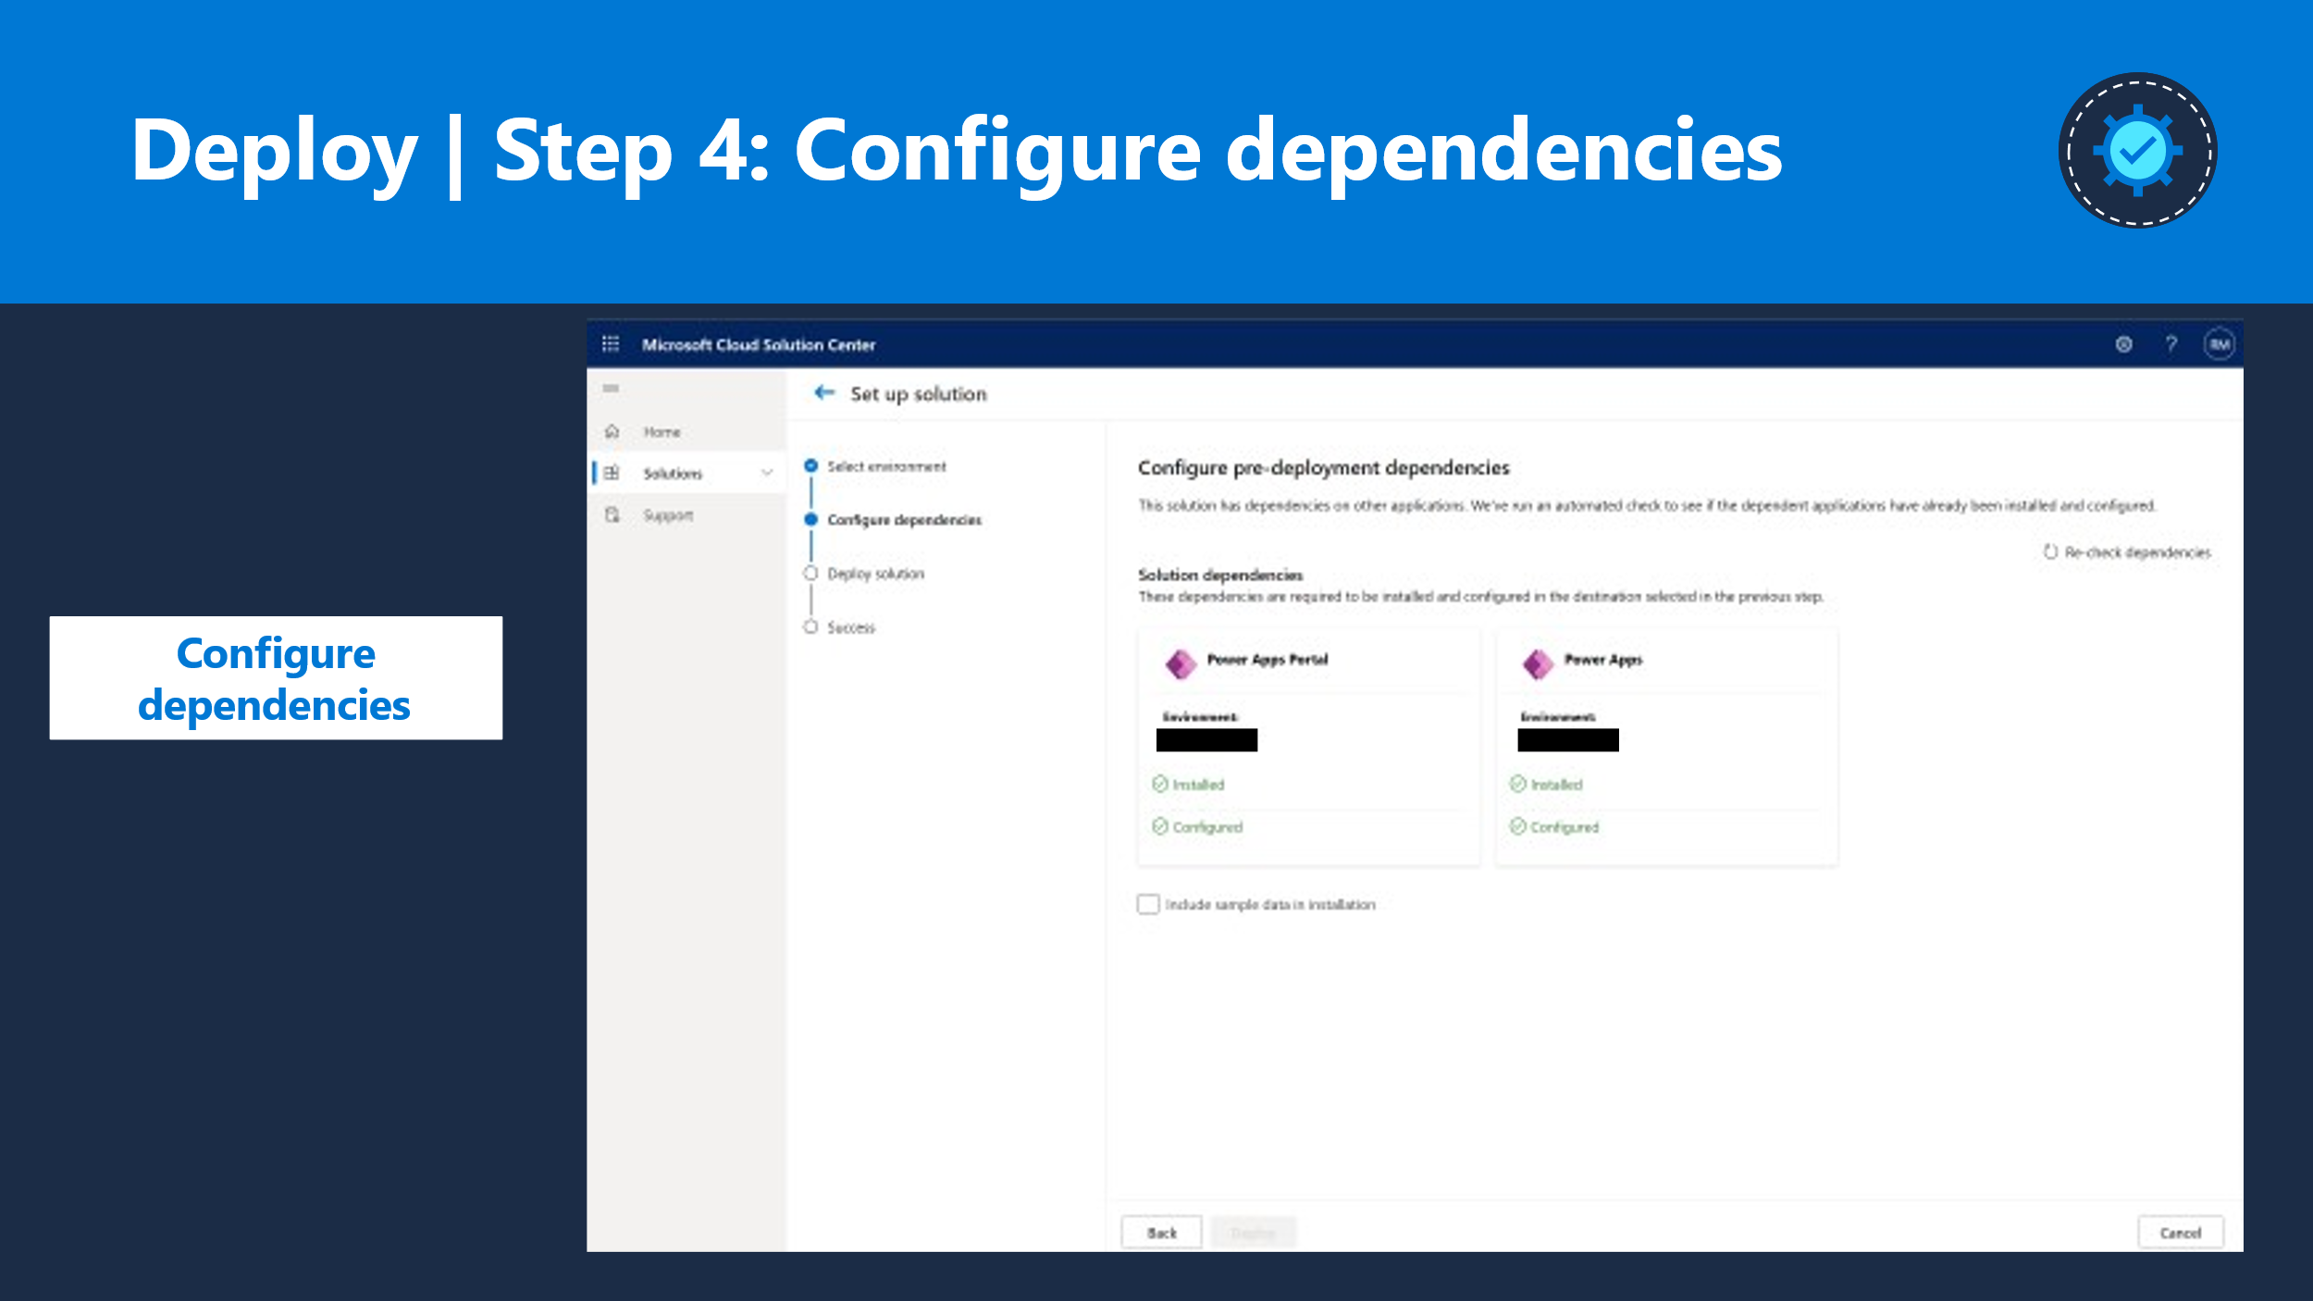

Once the dependency checkpoint is crossed, the installation process kicks in and you will see a progress status indicating the components that are getting deployed. Once ready you should receive a confirmation status from Solution Center indicating the success or failure of the deployment.

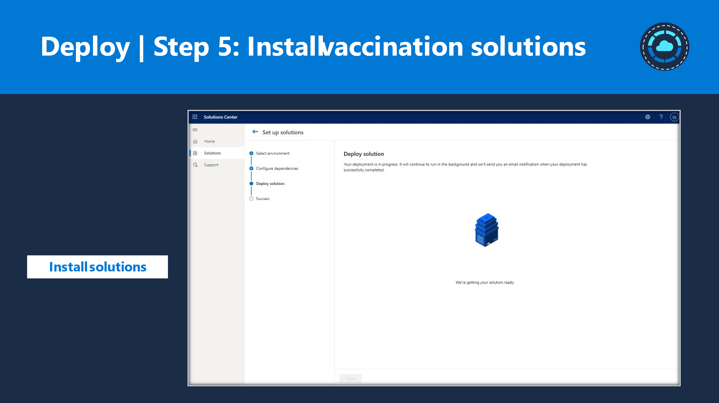

You can also track the solution status in Power Platform Admin Center under Dynamics 365 apps section.

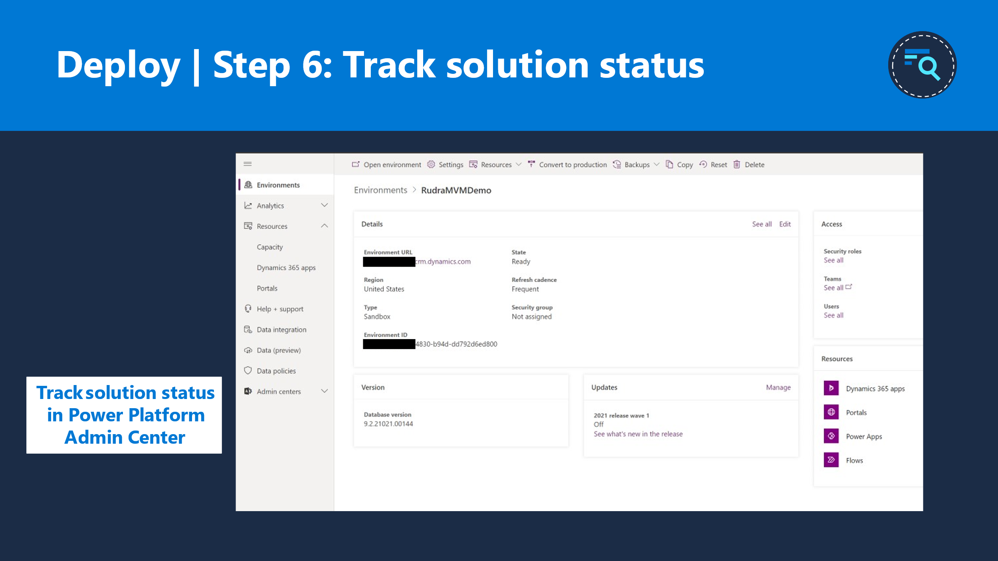

Once the installation is complete, you can begin the post deployment solution configurations in Solution Center.

